
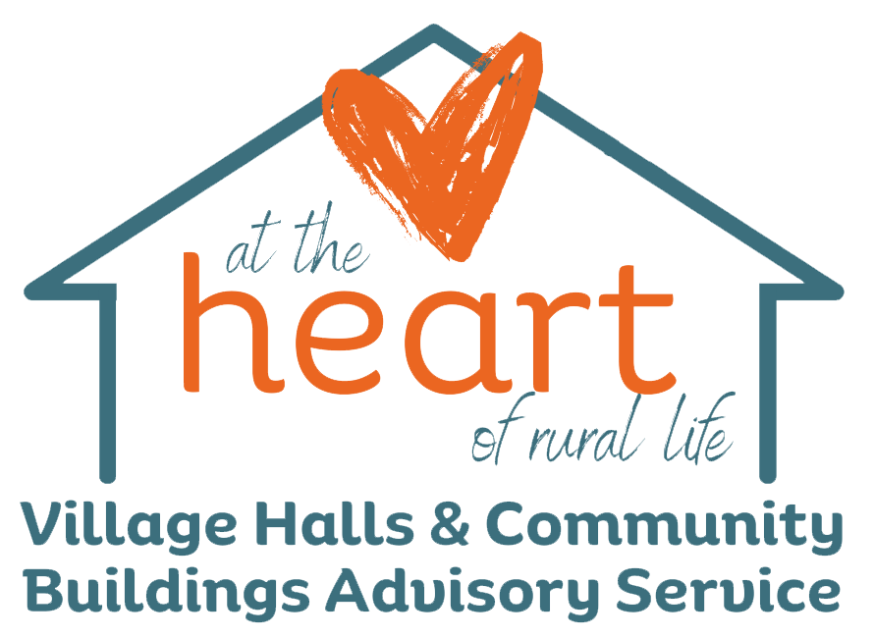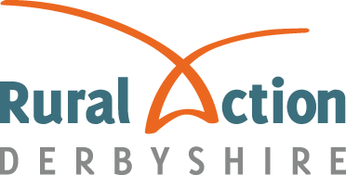

Rural Action Derbyshire, Town Hall, Bank Road, Matlock, DE4 3NN
01629 592970 www.ruralactionderbyshire.org.uk r.rawson@ruralactionderbyshire.org.uk

Publications for village halls and community buildings January 2024

Village Hall Information Sheets
(Please see reduced prices for multiple orders at the end of this list)

- Planning fees for village halls [November 2020] | £10
- Parish council help for village halls (October 2021) | £10
- Providing services in village halls [April 2021] | £10
- Data protection for village halls and community buildings [April 2021] | £10
- Safeguarding [April 2021] | £10
- Village halls and registration for VAT (Sept 2022) | £10
- Village hall insurance cover (May 2021) | £10
- Storage in village halls [June 2021] | £10
- Entertainment in village halls (January 2016) | £10
- The Charities Act 2011 (Feb 2022) | £10
- Village halls and car parks (Feb 2022) | £10
- Grant making and support for community groups (May 2021) | £10
- Asbestos (May 2015) | £10
- Health & safety legislation and village halls (December 2017) | £10
- Not in use
- Trustees – roles and responsibilities [June 2016] | £10
- Village halls and VAT on building work and other purchases (Nov 2017) | £10
- Marketing your village hall [Jan 2016] | £10
- Not in use
- Overnight accommodation in village halls [April 2022] | £10
- Managing employees and volunteers [December 2015] & addendum | £10
- Planning an extension refurbishment or new build village hall [Feb 2016] | £10
- Village halls, rates, waste and water [May 2015] | £10
- Making your village hall accessible [under review] | £10
- Coping with VAT on fuel and power supplies [April 2022] | £10
- Village halls and social clubs [under review] | £10
- Creating a business plan [Dec 2010] | £10
- Bingo in village halls [Jan 2011] | £10
- Village hall heating [Nov 2013] | £10
- Village hall flooring [Jan 2011] | £10
- Recruiting and retaining volunteers [Jan 2016] | £10
- Gaming and lotteries [Feb 2011] | £10
- Sale of goods in village halls [Feb 2011] | £10
- Trustee liability and trustee indemnity insurance [Sept 2013] | £10
- Village halls run by parish councils as sole trustee [Feb 2015] | £10
- Fire safety in village halls [April 2015] | £10
- Short guide to security in your village hall [May 2017] | £10
39. Village halls and incorporation (Sept 2013) | £10
40. Village halls, governing documents and title deeds (July 2021) | £10
41. Accounting and village halls [May 2017] | £10
42. Equality in village halls [2018] | £10

Prices for electronic copies only:
1@ £10, 3 @ £27, 5 @ £40, 10 @ £70, 20 @ £120 or full set @ £175 (If hard copies are requested, stationery & postage will be added)

ACRE Model Documents
Prices for the ACRE Model Documents below are also for electronic copies only. (If hard copies are requested, stationery & postage will be added)

Articles of Association for a village hall | £35
Preliminary Declaration of Trust | £35
Occupational Licence | £35
Lease of land and trust deed - Charity Commission approved | £35
Transfer of freehold land and trust deed – Charity Commission approved | £35
Model Hiring Agreement – 2016 | £35
Charitable Incorporated Organisation (CIO) Constitution for a village hall – Charity Commission approved – 2021 | £35
Charitable Incorporated Organisation (CIO) Constitution and Lease for a village hall – Charity Commission approved - 2021 | £35

Name
Organisation
Address
Post Code
Email
Phone No
Total cost | £

Please email your order, stating the number of copies you require in each box to: r.rawson@ruralactionderbyshire.org.uk

For payment by BACS: Rural Action Derbyshire Bank HSBC, Account No: 61473530, Sort Code: 40 17 15 (please indicate where or who is making the payment).

